How to create accessible documents
- A basic guide to Microsoft Word
The Department of Student Affairs, 2021

1. Introduction 3
2. Formalities 3
2.1 Table of contents 3
2.2 Headings 3
2.3 Fonts 4
2.4 Pictures 4
2.4.1 Images that provide meaningful information 4
2.4.2 Decorative images 5
2.4.3 Figuring 5
2.5 Tables and charts 5
2.6 Contrast 5
2.7 Header and footer 5
2.8 Document title 5
2.9 Section breaks and page breaks 6
2.9.1 Section breaks 6
2.9.2 Page break 6
3. Check the accessibility 7
4. Convert to a PDF 7

1. Introduction
How to create accessible documents – A basic guide to Microsoft Word has been developed to make it easier for the user to comply with the EU Web Accessibility Directive (2016/2102). The Web Accessibility Directive means that everyone must have equal access to digital content regardless of abilities.

2. Formalities
There is a lot to keep in mind regarding accessibility regarding formalities. Below are some tips and things to keep in mind when it comes to documents in Word. Note that this document and the screenshots apply to PC and Mac. However, what it looks like may differ depending on the version of Word.

2.1 Table of contents
Using a table of contents gives the document good readability and allows users to orient themselves. The table of contents should be at the beginning of the document. Place the cursor on the page where the table of content should begin. Go to References > Table of Contents. A prerequisite for this to work is that the format templates Heading 1, Heading 2, Heading 3, etc., are used in the document. Remove the “Contents” Heading in the list.
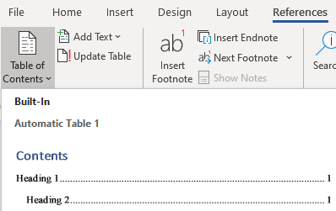

2.2 Headings
Use style sheets on the texts that are headings. The style sheets are located under the “Home” tab. The headings are written in hierarchical order, Heading 1, Heading 2, Heading 3, etc. The use of headings/style sheets is a prerequisite for creating a correct table of contents. Headings also allow the user to skip content. Remember to write descriptive headline text.
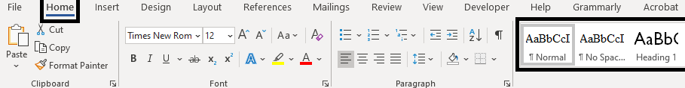

2.3 Fonts
All text (body text) that is not to be perceived as headings is written in “Normal.” Use a conventional font such as Times New Roman. The text should be at least 11 points; 12 is usually the default. Avoid italicized and underlined text.

2.4 Pictures
There are some things to keep in mind when it comes to pictures. The images must either have an alternative text that can be read aloud with a screen reader or marked as decorative. Avoid images with text as much as possible. Otherwise, the alternative text should be the same as in the image.

2.4.1 Images that provide meaningful information
Write alternative text for images to be described. Right-click on the image and select “Edit Alt Text.” The alternative text should describe the image´s purpose and not be longer than 100 characters.
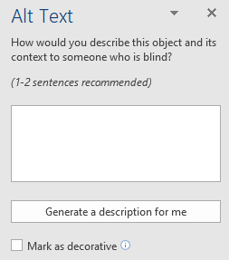

2.4.2 Decorative images
Only decorative images must be marked as a background image (artifact). Right-click on the image and select “Edit Alt Text,” then click on the box “Mark as decorative.”

2.4.3 Figuring
All images in the document must have an “In Line with Text” formatting so that the image does not float in the document.
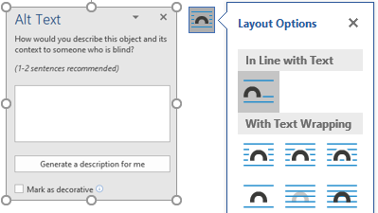

2.5 Tables and charts
When using tables, charts, etc., it is important to make sure that you do not only use color to carry information. The tables should also be clear visually and contain headings in each column/row. If lists are used, make a greater spacing between the bullets than the selected line spacing.

2.6 Contrast
Use sufficient contrast between text and background and in components and graphics.

2.7 Header and footer
Content placed in the header and/or the footer automatically becomes background (artifact) and is not read aloud with a screen reader. Avoid having important information and pictures here.

2.8 Document title
Make sure that the title of the document matches its content. Name the document by clicking File > Info > Properties. The title of the document is written here.

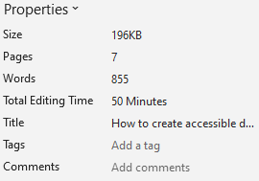

2.9 Section breaks and page breaks
Section breaks and page breaks can be advantageous in some cases, for example, if a new section/heading is to start on the next page. The document can be split using section breaks, and different formats can be made.

2.9.1 Section breaks
A section break is done by going to Layout > Section breaks > Next page. Place the cursor where you want the section to begin.
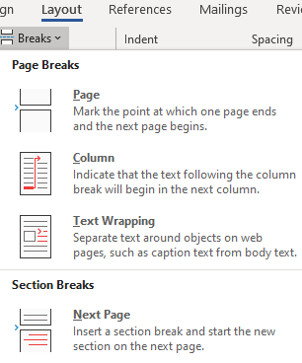

2.9.2 Page break
Page break is done by going to Insert > Page Break.

3. Check the accessibility
Word has a function where the user can check the accessibility of a document. Go to the “Review” tab and click on “Check Accessibility.” The check result shows whether the document is fully accessible or what needs to be done.
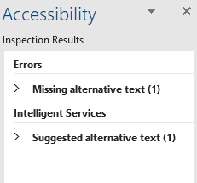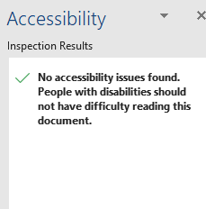

4. Convert to a PDF
To convert the document to a PDF, go to File > Save as Adobe PDF if you have an Adobe add-in.

